Establishing a Development Environment for Python Projects

In this document, I outline the process of establishing a development environment specifically tailored for Python projects. This guide details the installation and configuration of essential tools and resources, culminating in a documented workflow and a sample project repository.

1. Selection of Operating System (OS):

The initial step involved selecting a suitable operating system (OS) upon which to construct the development environment. In this instance, Windows 11 was chosen due to familiarity and established workflow.

2. Text Editor/Integrated Development Environment (IDE) Installation:

Following OS selection, the installation of a text editor or integrated development environment (IDE) specifically suited for Python development was undertaken. Visual Studio Code was chosen for this purpose due to its lightweight nature, extensive customization options, and robust ecosystem of extensions specifically designed for Python development. I am currently using the monokai theme for my VS code as seen below.

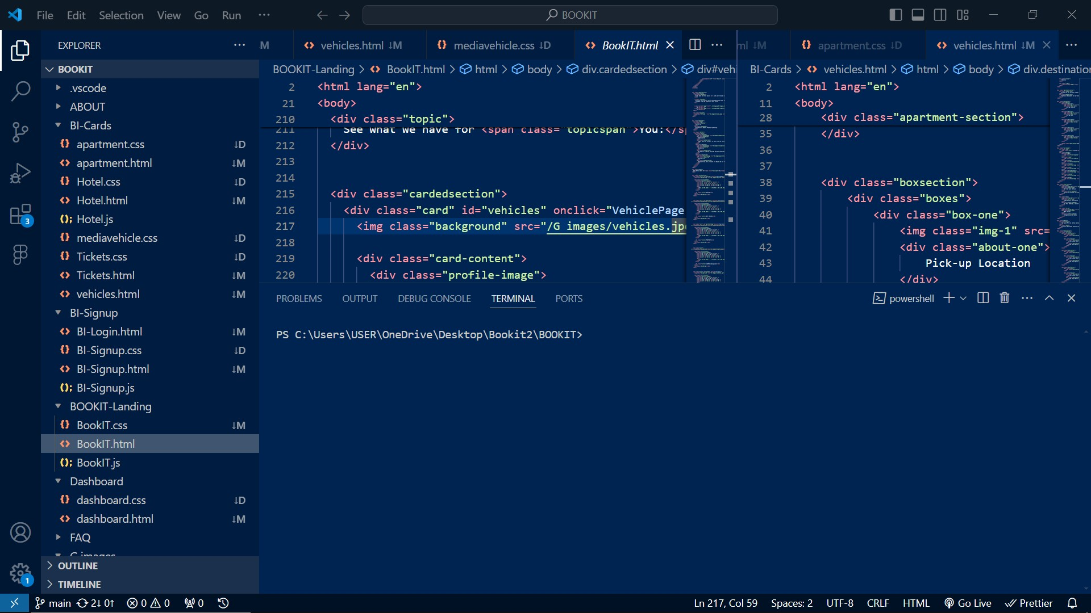

3. Version Control System Implementation:

To facilitate code version tracking and collaboration with potential team members, the Git version control system was installed on the local machine. Subsequently, a free account was established on GitHub, a popular platform for hosting code repositories. This was followed by the initialization of a Git repository within the project directory on the local machine. Finally, the initial commit was made, capturing a snapshot of the project's codebase at this point in time.

PS C:\Users\USER\OneDrive\Desktop\myhomeetal-admin\myhomeetal-admin-website> git init

Reinitialized existing Git repository in C:/Users/USER/OneDrive/Desktop/myhomeetal-admin/myhomeetal-admin-website/.git/

PS C:\Users\USER\OneDrive\Desktop\myhomeetal-admin\myhomeetal-admin-website> git add .

warning: LF will be replaced by CRLF in app/page.tsx.

The file will have its original line endings in your working directory

warning: LF will be replaced by CRLF in public/icon/cart-check.svg.

PS C:\Users\USER\OneDrive\Desktop\myhomeetal-admin\myhomeetal-admin-website> git commit -m 'admin dashboard'

[master 98a35f8] admin dashboard

20 files changed, 238 insertions(+), 113 deletions(-)

create mode 100644 app/(main)/page.tsx

create mode 100644 public/logo.svg

PS C:\Users\USER\OneDrive\Desktop\myhomeetal-admin\myhomeetal-admin-website> git push …

4. Python Installation and Configuration:

Python was then installed. The latest version of Python was downloaded from the official website (https://www.python.org/). This ensures access to the most recent features and functionalities offered by the language.

5. Package Manager Consideration (Optional):

I installed the package manager pip. Package managers simplify the process of installing and managing additional libraries and tools that may be required by the project in this case, python.

6. Database Configuration (Optional):

I installed mysql workbench for scenarios where projects necessitates data storage, the installation of a database server, such as MySQL, might be required. This step is entirely optional and should be determined by the project's specific data management needs.

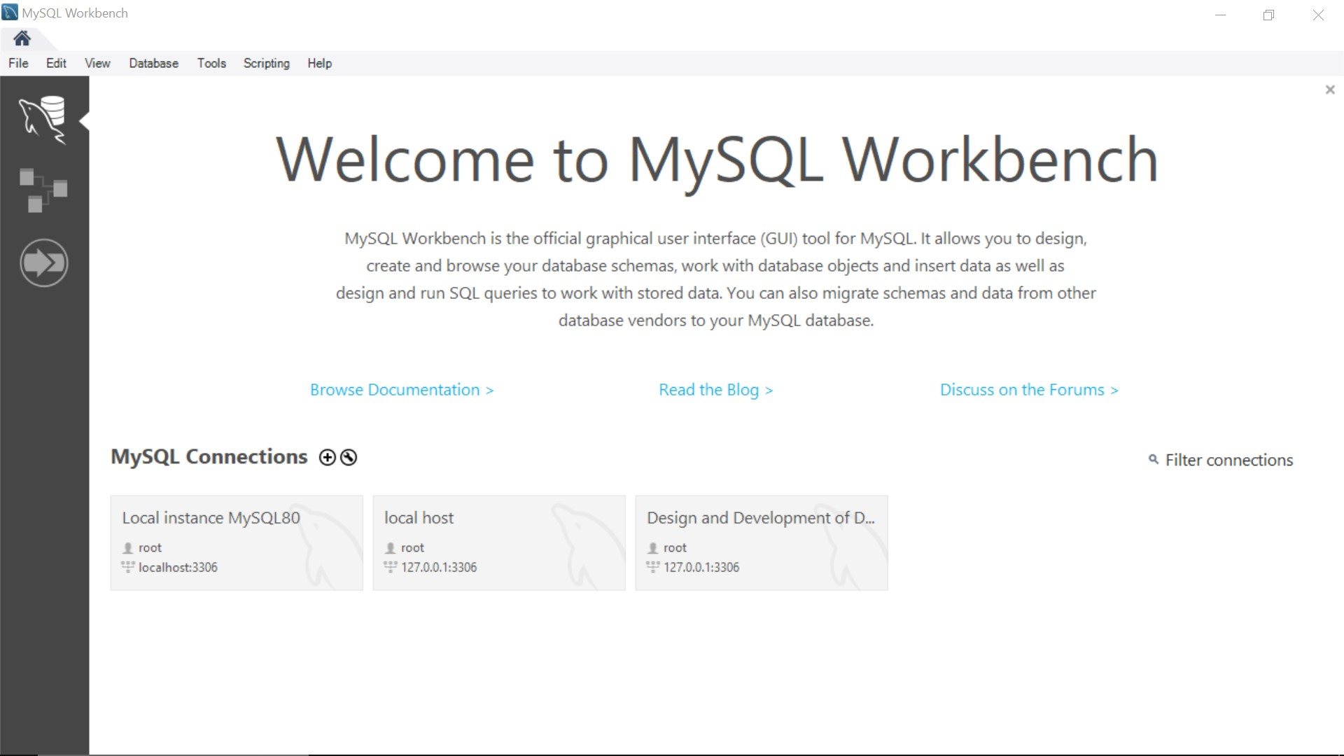

7. Development Environment Isolation (Optional):

For more intricate projects or those involving multiple versions of Python or libraries, the utilization of tools like Docker or virtual machines might be considered. These tools offer advantages in isolating project dependencies and guaranteeing consistent environments across different machines. The implementation of these tools is considered more advanced and might not be necessary for simpler projects.

8. Editor/IDE Extension Exploration:

To enhance the coding experience within Visual Studio Code, an exploration of available extensions and plugins specifically designed for Python development was conducted. Valuable extensions were identified, including those providing syntax highlighting, code linting (checking for stylistic errors), code formatting, and Git integration. These tools collectively contribute to increased productivity and improved code quality.